Issues found 28-06-26 at 0934 review
- Duplication of live UK 2026-1 and mymoney bar is not approproriate for taxation

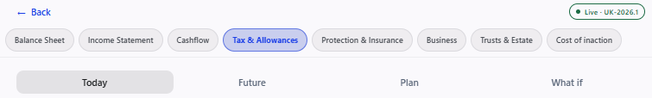
2 Poorly designed we discussed many times its easy to categorise into drawers and then make tiles to investigate all options with detailed information about each tile.
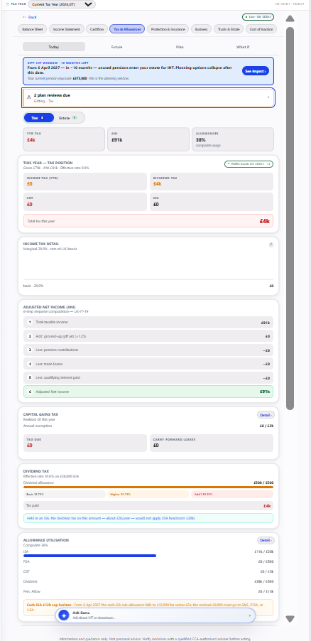
3) Need to organize correctly and simple english
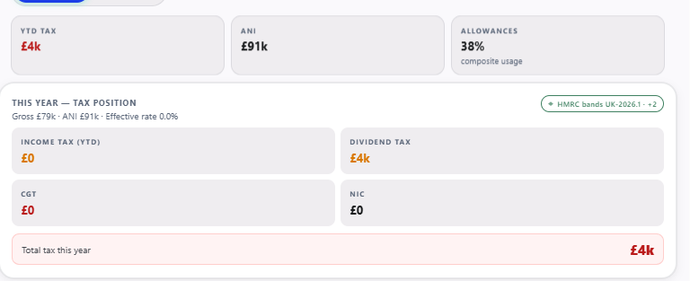
4) Blank tile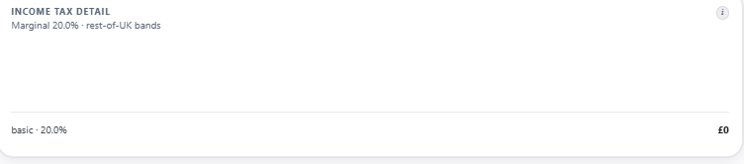
5) What is the point of this and why cant I drill down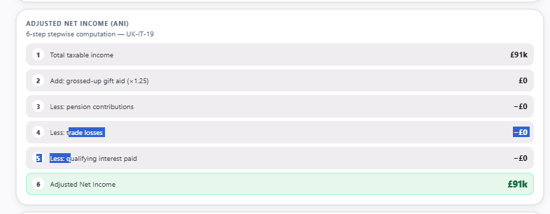
6) Every other pill needs evaluating and fixing
7) choices at the bottom of the screen should be at the top
8) No where to load any tax information like self assessment and other tax documents you have to have this and research into this
9) Predict taxation
10) What about what I haven’t used yet
11) You need to research into what tax and estate information we need for this tab and then organize it in a way that’s meaningful at this moment – its lacking domain knowledge and design principles let alone informative

